If you have never used Zoho Meeting before, there are a few screens that you need to move through, the first time, before you are completely launched as see my screen. After you click on the zoho link we send you, you’ll see:

We allow cameras by default, but you can keep yours off if you want.

Type in your name if there are multiple people in our meeting at different locations logging in. Most of the time Computer Audio is chosen, but if you want to use phone, click the **Join via phone audio** link

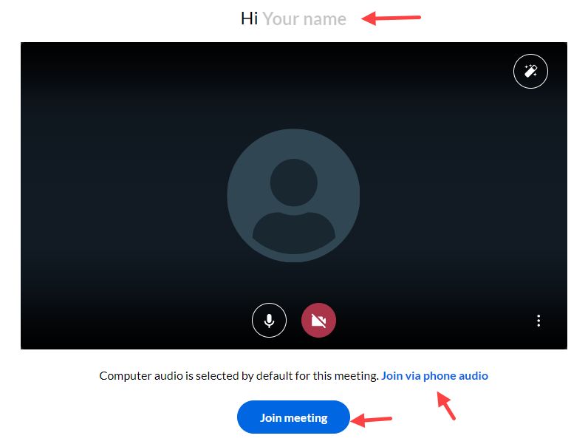

#1 is the information you’ll see to dial in by phone IF you choose “Join via phone audio.”

#2 is what you’ll see if you are in the phone audio area and decide to choose the default, Computer Audio option.

If you clicked the blue Join meeting button, you should next see the connection screen.

This is an announcement you might see. If so, choose Skip

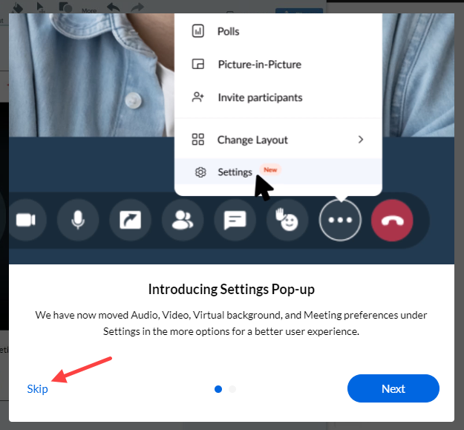

Now you see Civic Clarity’s screen. We’ll have the following 3 steps on top of the demo website. **If you do not see a menu bar at the bottom of your screen, mouse over the bottom of the screen and the menu will pop up and be visible.**

Change the layout to make it easier to view the demo website.

